# MacBook Pro Quick Start

Table of Contents

**MacBook Pro Quick Start** **1**

**Chapter 1: How to Turn on the MacBook** **3**

**Chapter 2. How to Connect to a Network** **5**

# Chapter 1: How to Turn on the MacBook

This explains how to get started using your MacBook.

In order to turn on your MacBook you need:

* Your MacBook
* Apple MacBook Pro charger type c

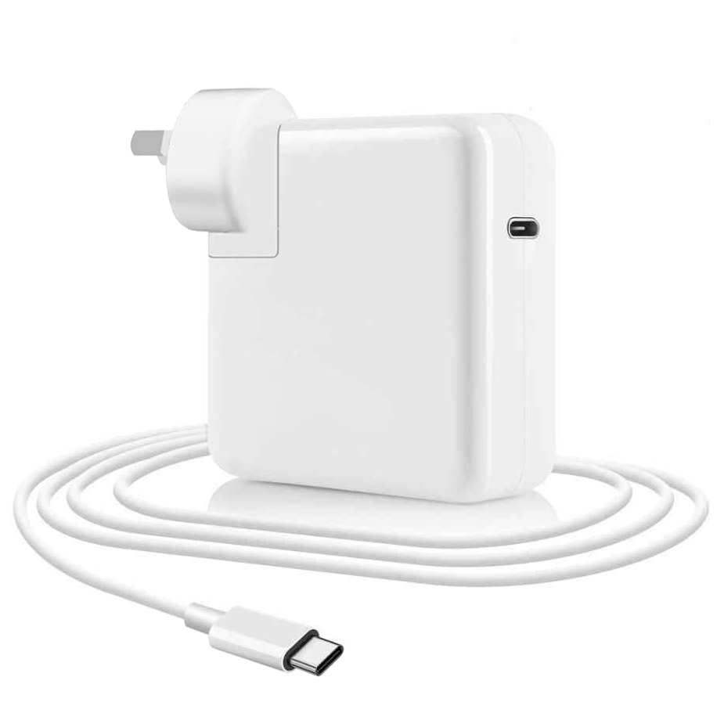

Find an outlet nearby.

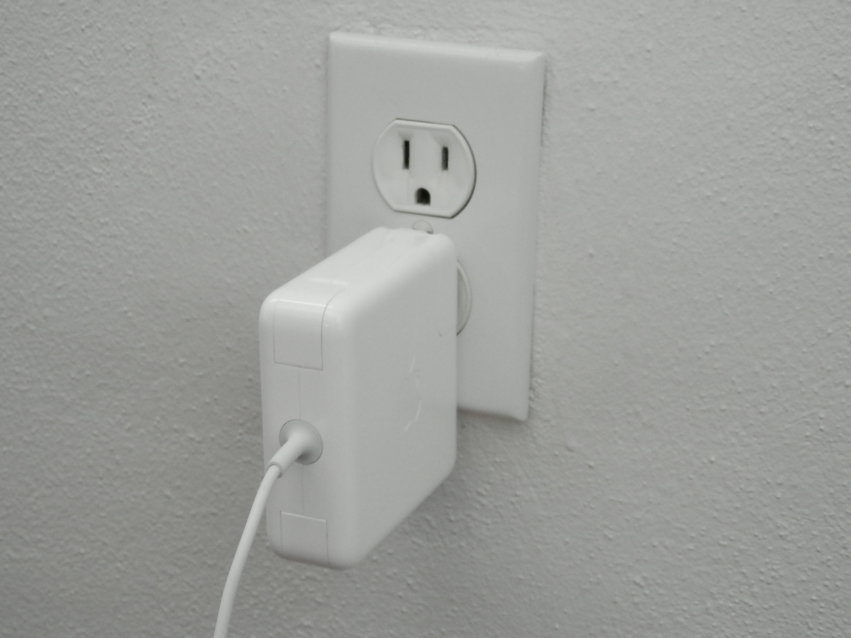

1. Connect the charger to the MacBook Pro

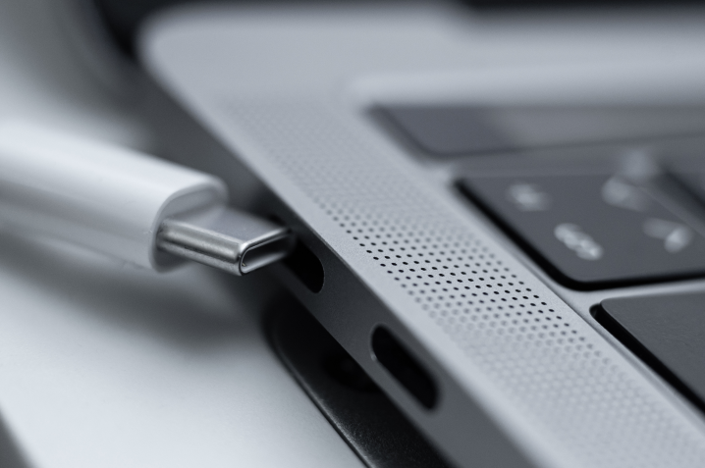

3. Press and hold the power button in the keyboard's top-right corner

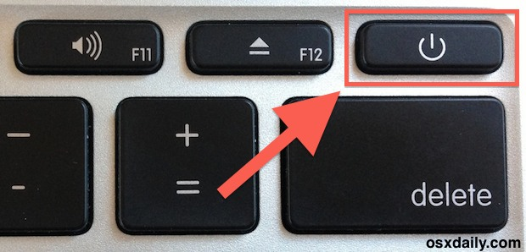

# Chapter 2. How to Connect to a Network

This chapter provides information on how to connect to the internet.

In order to connect to the internet, you need:

* A wireless router
* MacBook Pro

Once the MacBook is turned on:

1. Search Network on the search bar and click on it

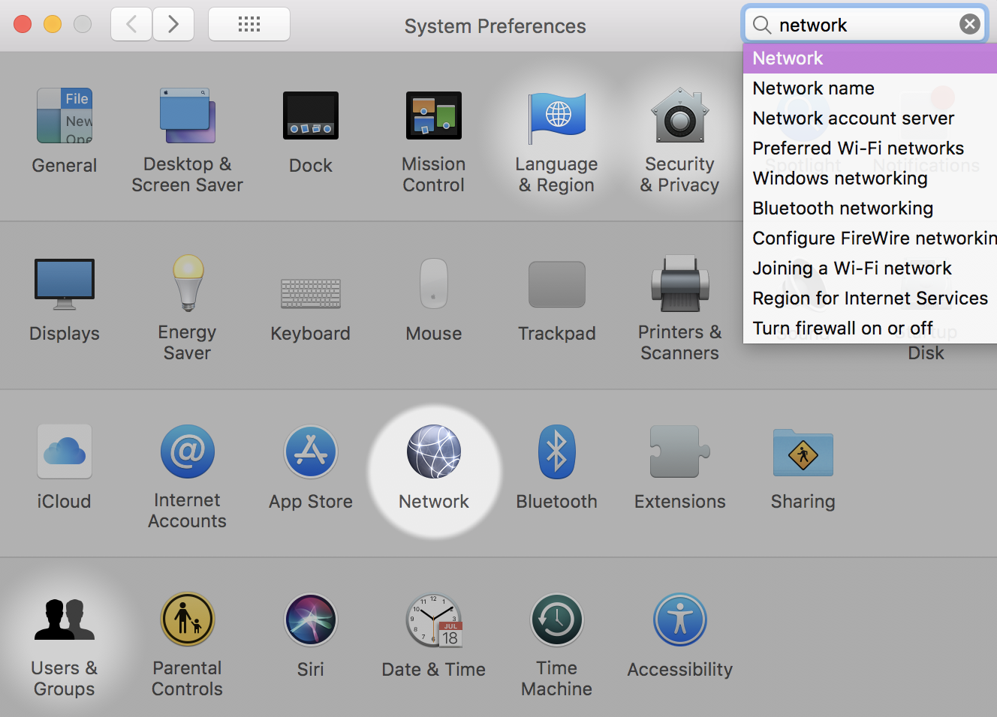

1. Find your local wireless router name and enter your password to connect

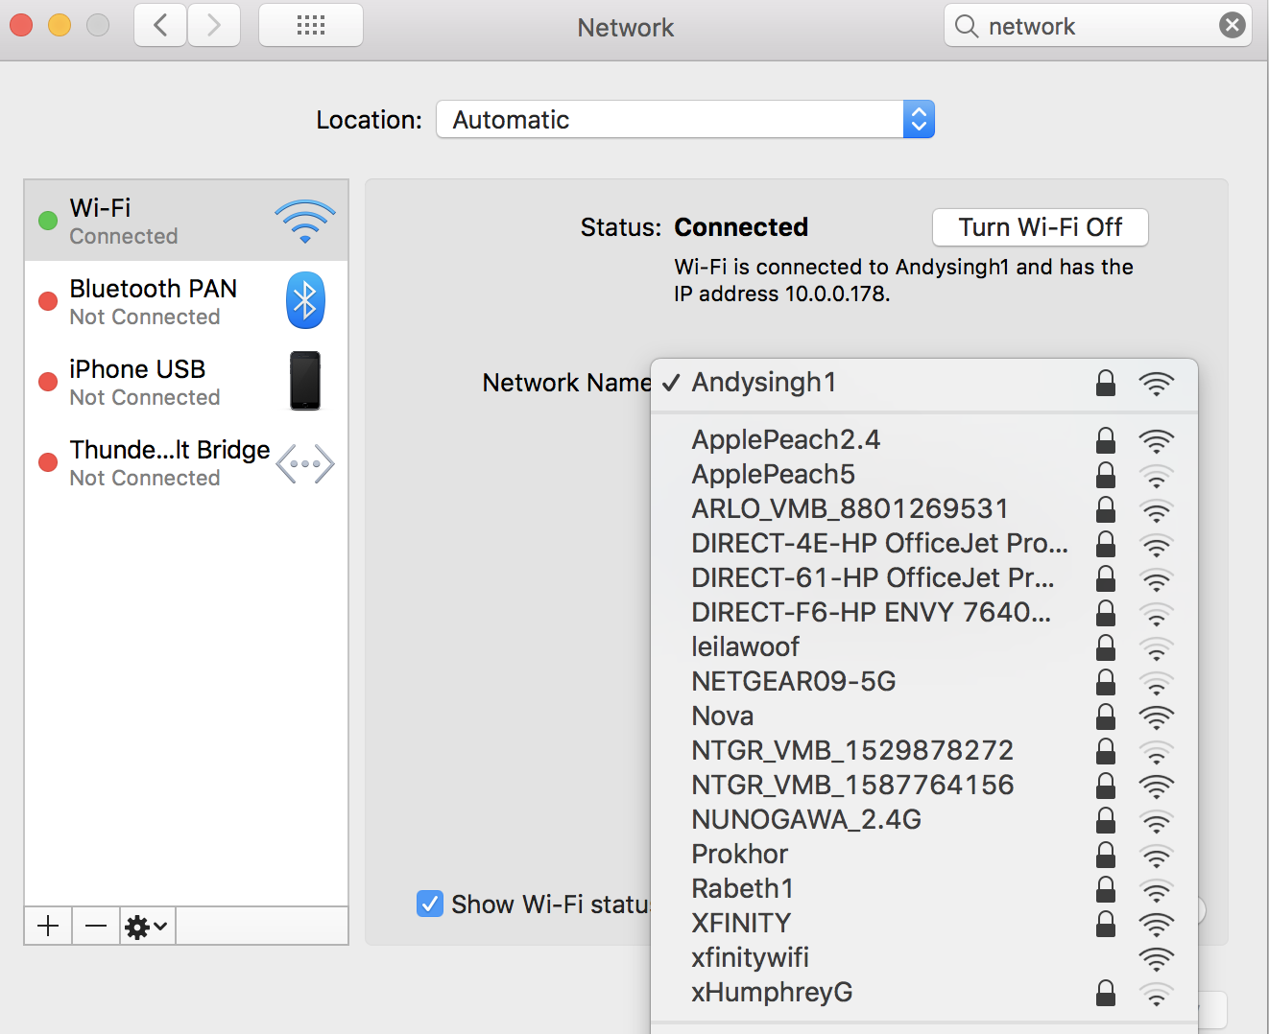

4. You are successfully connected to the internet.