Nintendo Switch Quick Start

Table of Contents

**1. Locate your Nintendo Switch AC Adapter** **3**

**2. Plug the AC Adapter into the USB Connector on your switch's underside.** **3**

**5. Once your Nintendo Switch is powered on, a prompt will appear on the screen. Please proceed by following the on-screen instructions.** **4**

**5.5 Select the correct time zone.** **6**

**5.6 Establish a profile for your Nintendo Switch.** **7**

**5.7.3 Select a profile picture. To view additional options, click on "More Options."** **8**

# Locate your Nintendo Switch AC Adapter

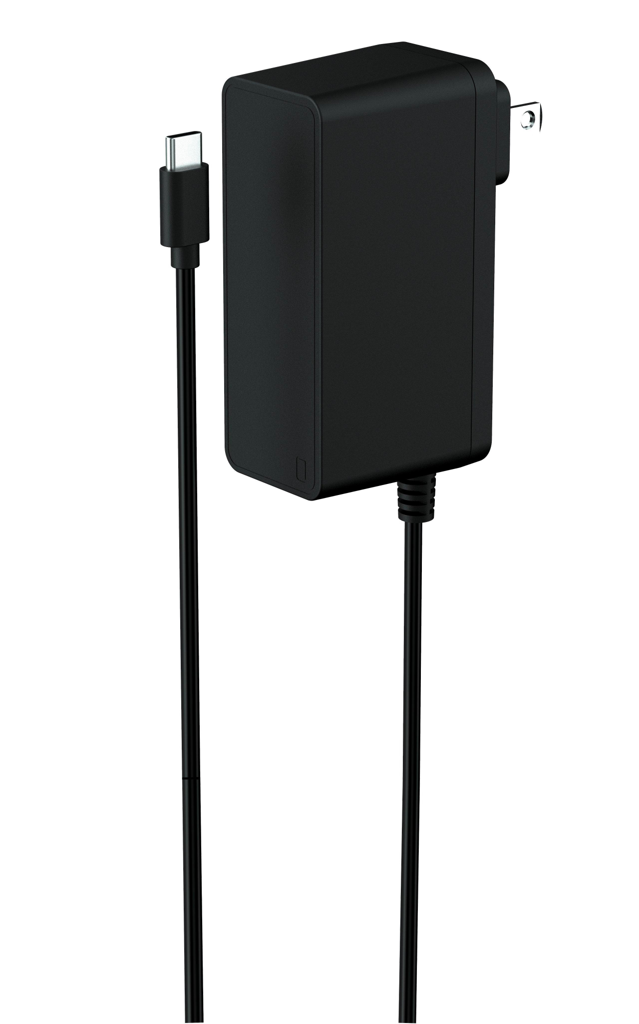

*The AC Adapter comes with the Nintendo Switch*

# Plug the AC Adapter into the USB Connector on your switch's underside.

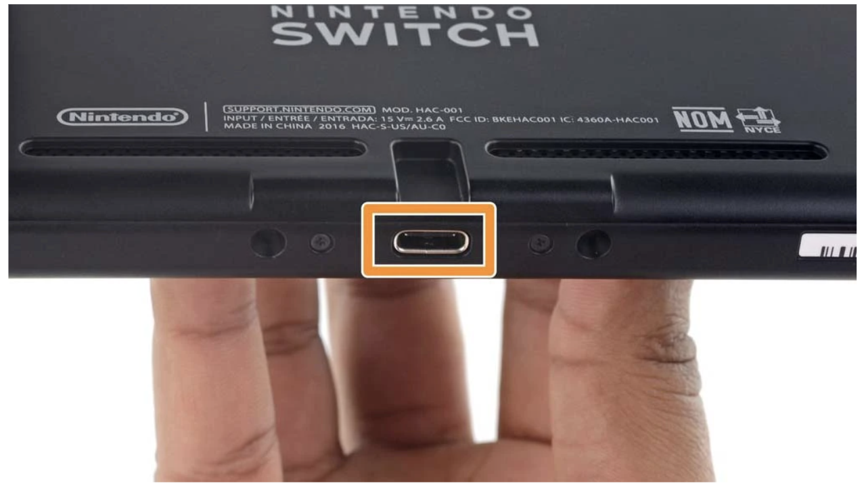

1. Connect the AC Adapter to a wall outlet nearby.
2. Power on the Nintendo Switch using either the HOME Button or the POWER Button.

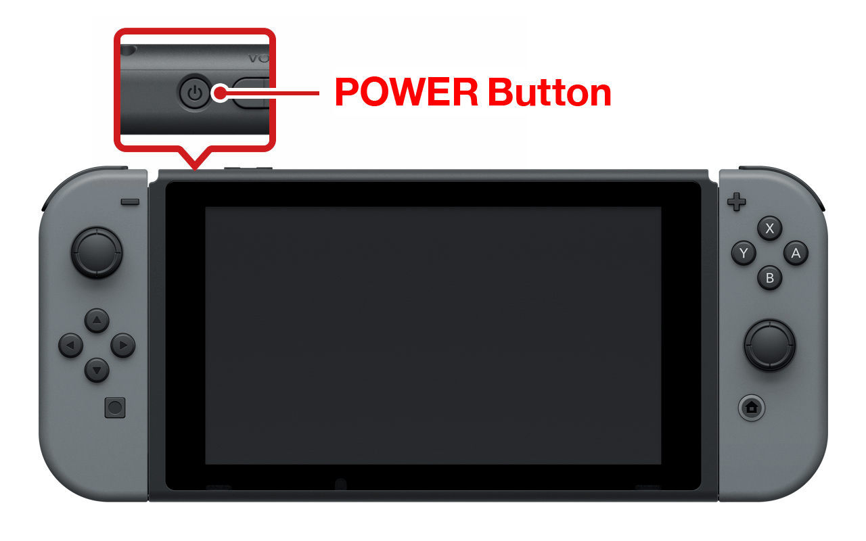

*The Nintendo Switch Console features the Power Button positioned at the top, while the Home Button can be found on the right Joy-Con controller.*

# Once your Nintendo Switch is powered on, a prompt will appear on the screen. Please proceed by following the on-screen instructions.

5.1 Choose the correct language for your Nintendo Switch.

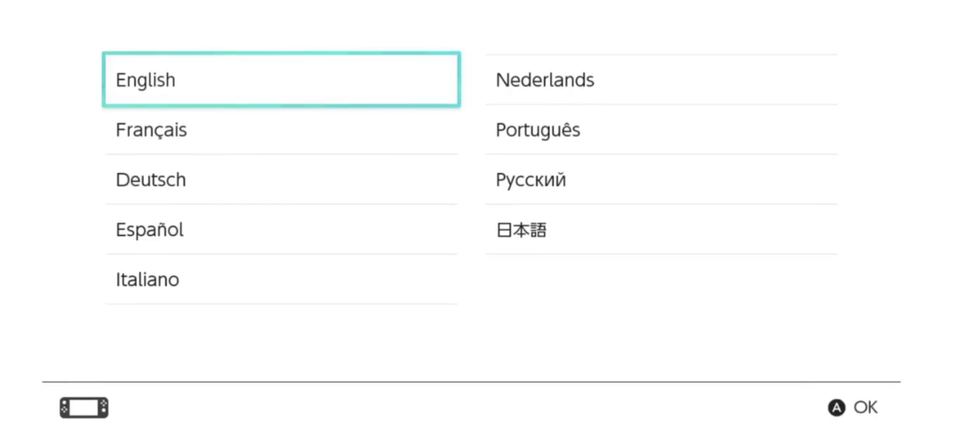

5.2 After selecting a language, proceed to select the suitable region.

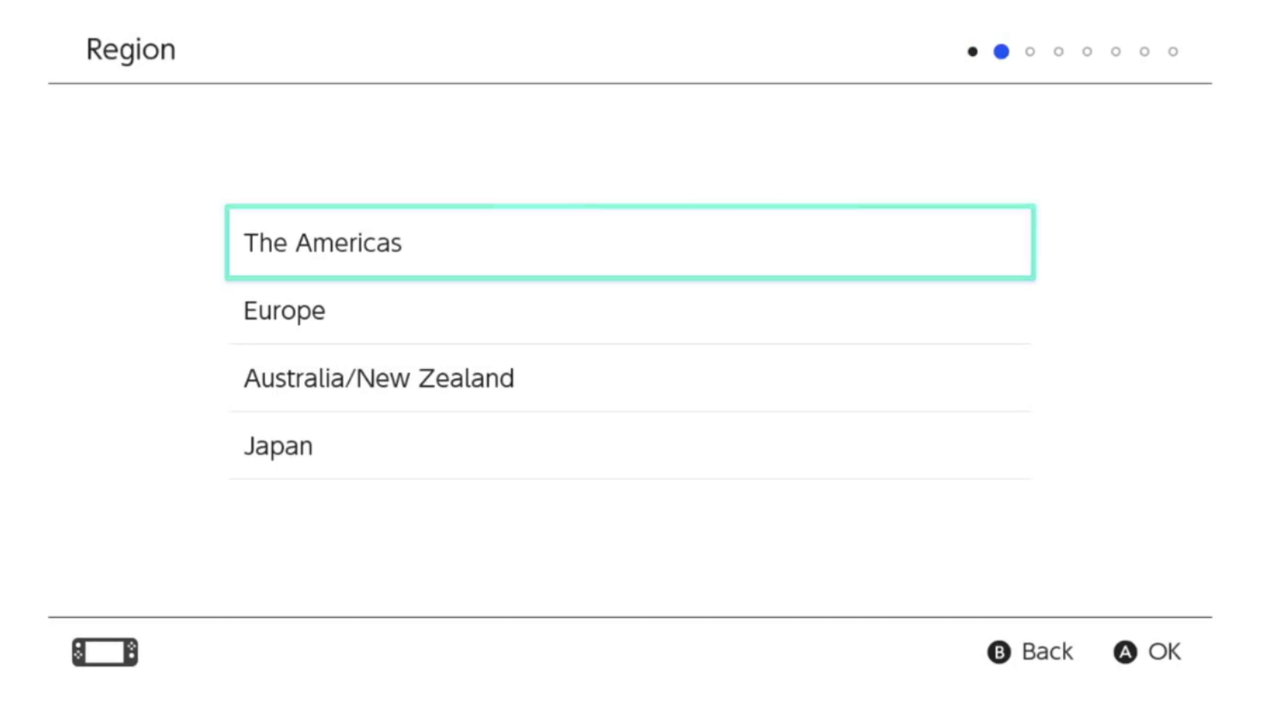

5.3 Read and then choose "Accept End-User Service Agreement."

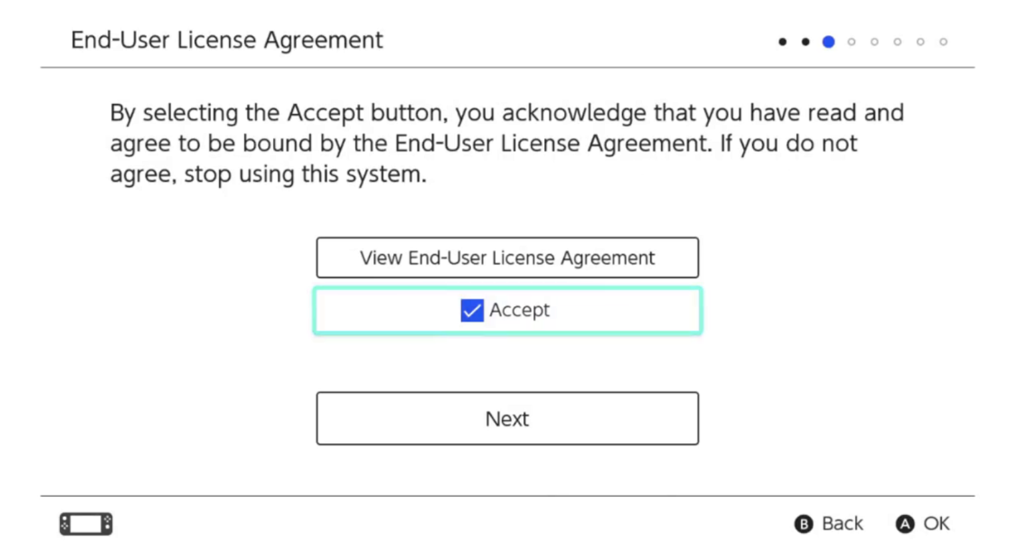

5.4 Connect to the Internet.

5.4.1 Choose the appropriate router.

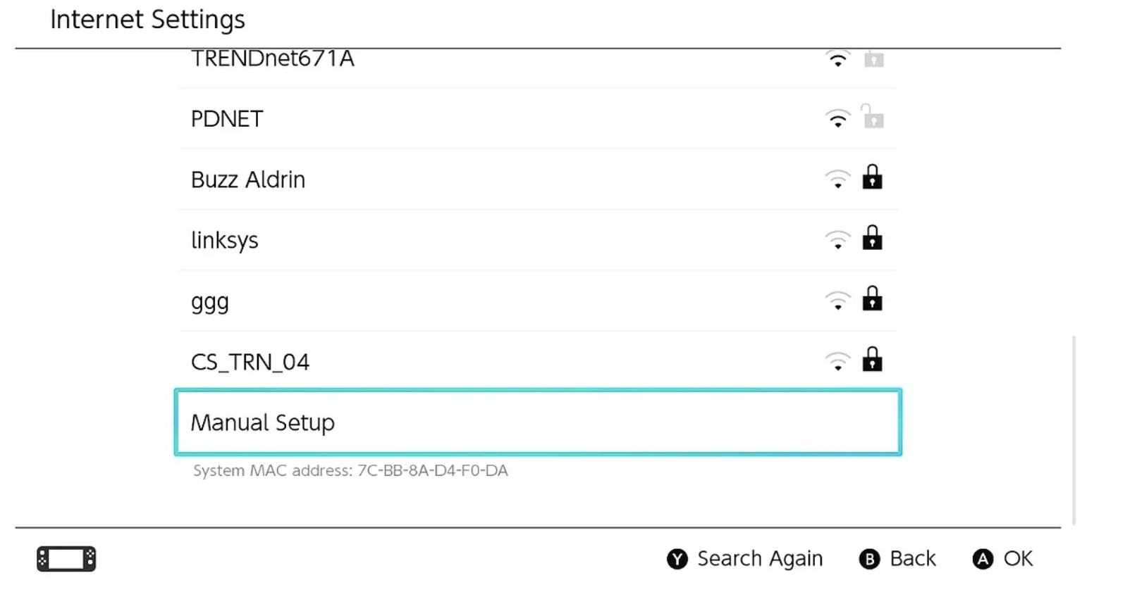

5.4.2 Read and then choose "Accept End-User Service Agreement."

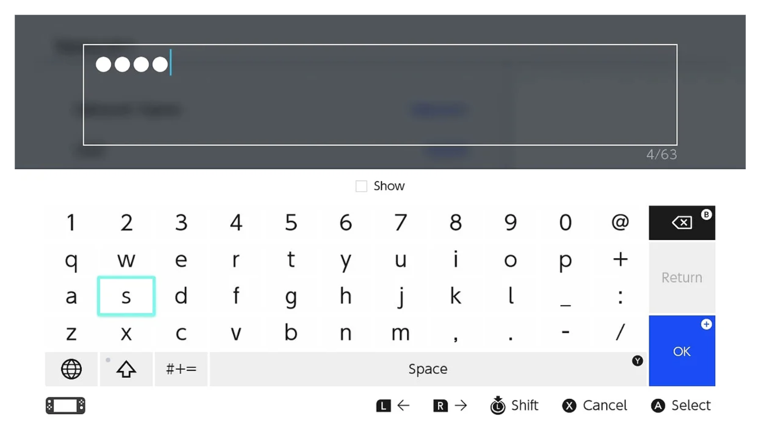

# 5.5 Select the correct time zone.

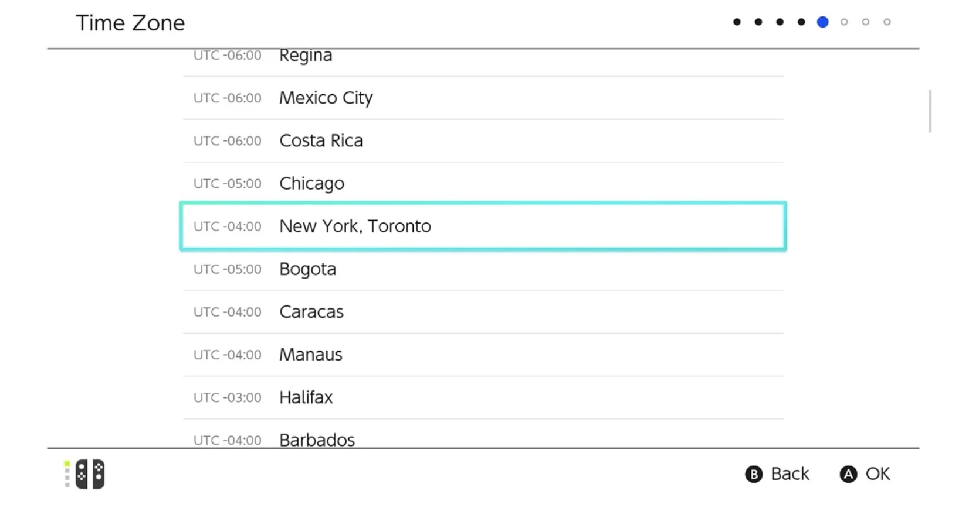

# 5.6 Establish a profile for your Nintendo Switch.

5.6.1 Click on the "Next" button.

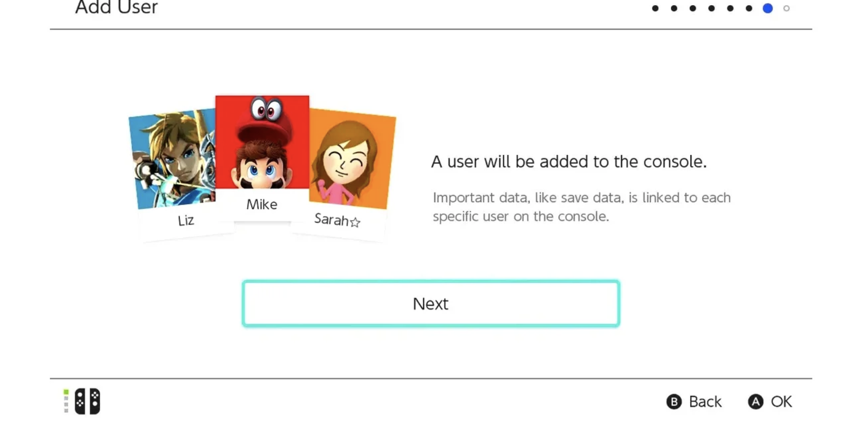

5.7.2 Choose "Create a New User" (if you do not already have an account).

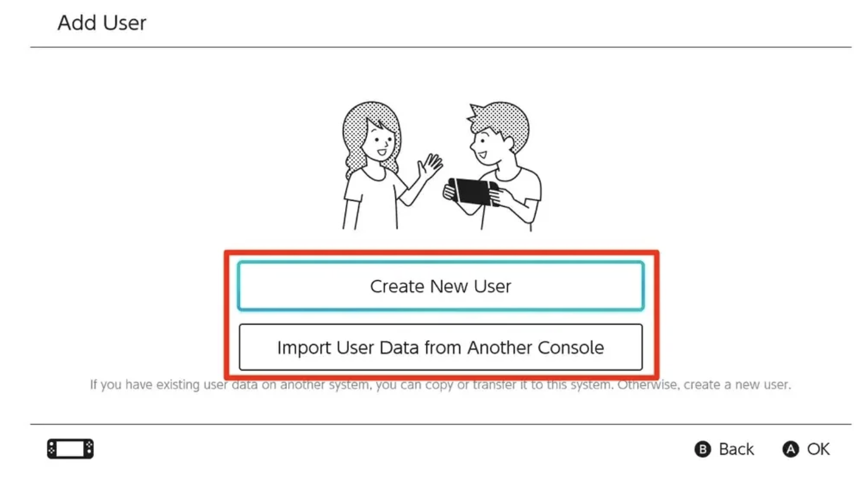

# 5.7.3 Select a profile picture. To view additional options, click on "More Options."

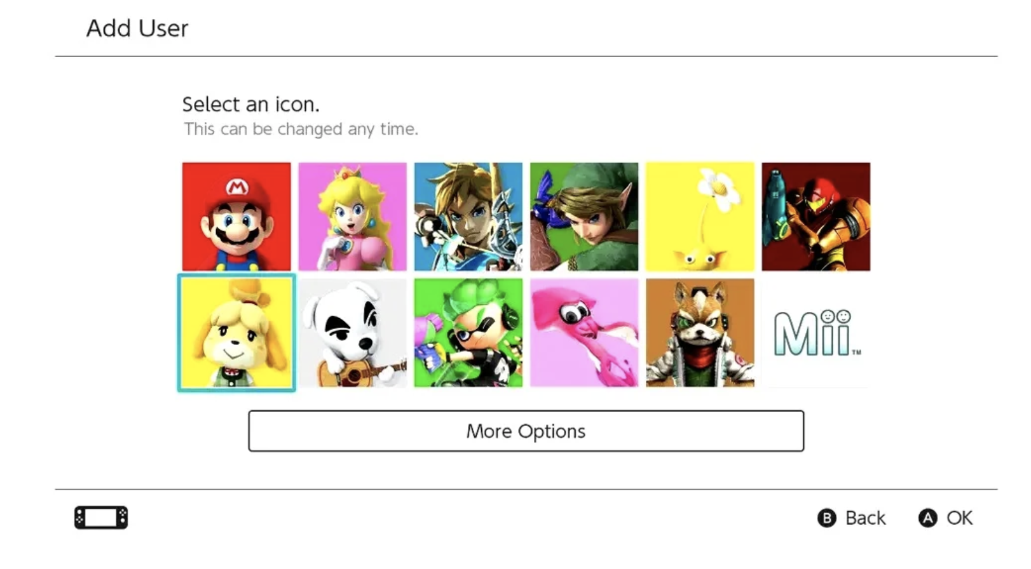

5.7.4 Input a nickname.

5.8 Push the HOME Button located on the right Joy-Con.

